Jeffrey Razon

Argenis Jimenez

CPE 403-1001

NSHE 2000718323

CC1350 Lab 3

Github root directory: https://github.com/JeffinVegas/403_AdvEmbSys

Date Due: November 19th, 2018

Youtube Link (Task 7): https://youtu.be/m4-Mnnx-CSE

**Task 1**: SmartRF Studio ↔ SmartRF Studio

We were able to transfer/receive packets in RF Studio.

**Task 2**: Importing and running the rfPacketTx example

We were able to import, build, and run the rfPacketTx example.

**Task 3**: Exporting and using RF configuration

We were able to change the RF settings

**Task 4**: Firmware TX → SmartRF Studio RX

We were able to receive packets using both RF Studio (TX) and CCS (RX)

**Task 5**: Importing and Modifying rfPacketRx

We were able to import, build, and run the rfPacketRx.

**Task 6**: Firmware TX → Firmware RX

We disconnected the device and reconnected the devices and transfer/receive packets.

**Task 7**: SmartRF Studio TX → Firmware RX

We connected the TX launchpad to RF Studio and transfer/receive packets.

Photos:

a) RFStudio menu

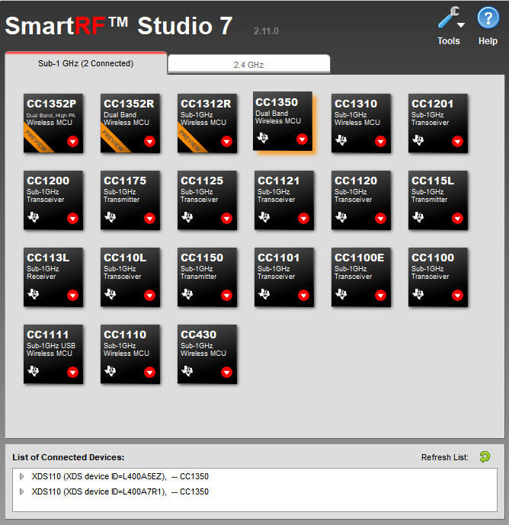

b) RX menu

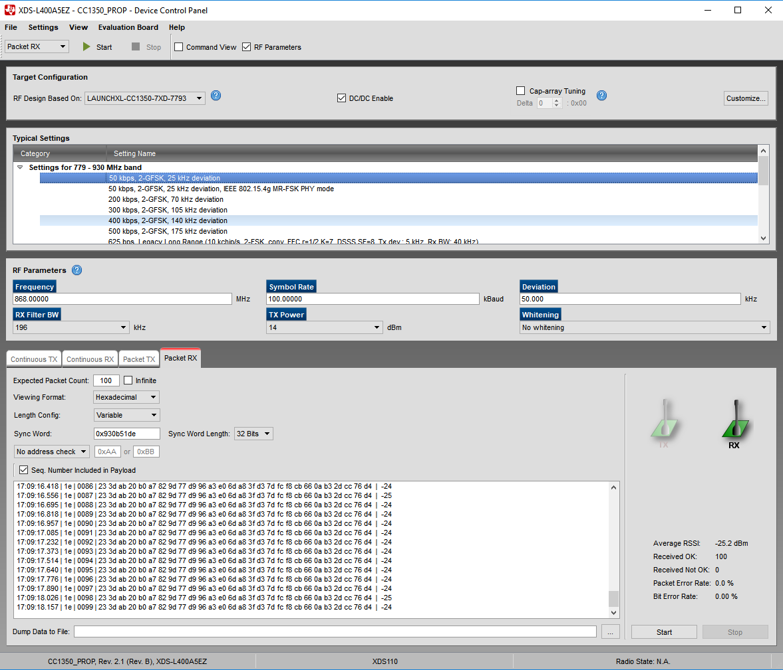

c) TX menu

